

**PRESS RELEASE** Prague, XX June 2020

# Building A wins HOF Award for Best Reconstructed Commercial Project

**The HOF Awards (Hall of Fame – Best of the Best) recognised the best projects, companies and personalities from the area of the real estate market across the entire CEE region. Building A in Prague’s BB Centrum, which has the investment and development company Passerinvest Group behind it, won first place in the category of Best Reconstructed Commercial Property in competition from projects from the Czech Republic, Hungary, Poland, Romania, Serbia and Slovakia. This year, the announcement of the results and the acceptance speeches took place in the form of a live stream on 27 May. The organiser of the awards is Roberts Publishing Media Group, the issuer of the professional real estate magazine CIJ.**

*“For us, the recognition in the Hall of Fame – Best of the Best awards for the Best Reconstructed Commercial Project for Building A is a confirmation that we are performing good, high-quality work.* I would like to thank my colleagues and everybody who contributed to this sensitive and effective reconstruction and who keep BB Centrum attractive and popular,” Radim Passer, the founder and CEO of Passerinvest Group, stated with regard to receiving the award.

In 2018, the office Building A in Prague’s BB Centrum underwent a complete renovation of its outer shell and interiors. The reconstruction of the building with a total leasable space of 21,600 m2 took place in cooperation with its sole tenant, the leading Czech bank MONETA Money Bank, whose headquarters are in Building A. The author of the renovation design is the A8000 architectural atelier. The building is owned by the investment and development company PASSERINVEST GROUP that, as a responsible urban investor, is constantly developing the BB Centrum complex and modernising the existing buildings so that they continue to offer first-rate services.

[**HOF AWARDS BEST OF THE BEST**](https://hofawards.eu/) recognise the projects of the year from the areas of offices, retail, residential and logistics properties, as well as companies operating on the real estate market (real estate agencies, construction companies), as well as banks and project managers. The HOF Awards were founded in 2016 in order to find the winners of the Best of the Best awards from the region of Central, Eastern and South-eastern Europe among the winners of the CIJ Awards in the individual countries, which automatically are nominated for the HOF Awards.

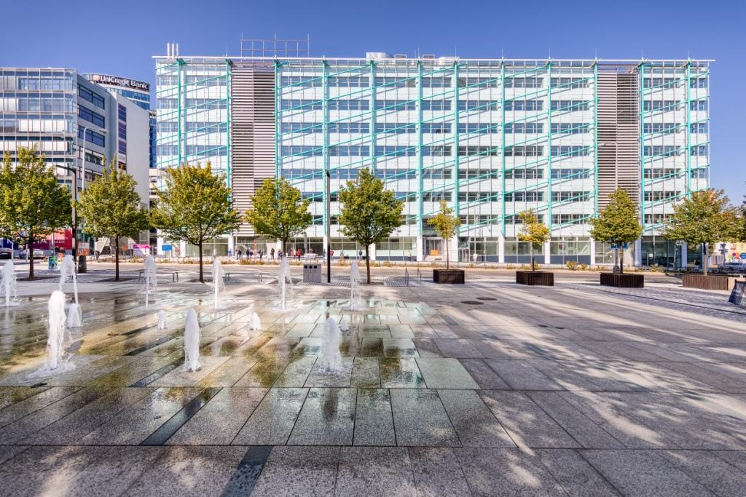

Front view of reconstructed Building A in BB Centrum



Rooftop terrace of reconstructed Building A in BB Centrum

You can get more information and photographs in print quality from:

Kristýna Samková**,** Head of PR and Marketing Department

**PASSERINVEST GROUP, a.s.**

Tel.: (+420) 221 582 111

E-mail: [Kristyna.Samkova@Passerinvest.cz](mailto:Kristyna.Samkova@Passerinvest.cz)

[www.passerinvest.cz](http://www.passerinvest.cz/)[www.bbcentrum.cz](http://www.bbcentrum.cz)

Marcela Štefcová

**Crest Communications a.s.**

Mobile: (+420) 731 613 669

E-mail: marcela.stefcova@crestcom.cz

**About the company**

[**Passerinvest Group, a. s.**](https://www.passerinvest.cz/) is a purely Czech development and investment company founded and managed by Radim Passer. Passerinvest Group considers its social responsibility to act as an authority in its field and in society, thus both in the role of a long-term partner to the city, with the goal of transforming often dismal territories into pleasant and user-friendly localities, and in an educational, supportive and moderating role in socially important areas, i.e. the development of the Czech Republic through transportation initiatives or education in the area of health and human values. Since 1998, Passerinvest Group, as a responsible urban developer, has primarily been connected with [**BB Centrum**](https://www.bbcentrum.cz/) in Prague 4, which is one of the most successful and extensive urban projects not only in the Czech Republic, but throughout all of Europe.

Another important project in the Passerinvest Group’s portfolio is [**Nové Roztyly**](http://www.krcakzije.cz/). The current brownfield of the former Interlov complex where, in the future, a place with pleasant housing with a large amount of greenery should arise, complemented by services for the general public and an office function. Apart from the projects in Prague, the company also built and owns the Ostrava office building [**Nová Karolina Park**](http://www.novakarolinapark.cz/cs).

The principles of urban construction and the long-term sustainable development of Prague and the Czech Republic are part of Passerinvest Group’s vision. Thanks to its responsible approach, Passerinvest Group has built a very good reputation both on a domestic and an international level. This is not only to the credit of the quality of the realised projects and the high level of the provided services, but also to the sense of fair play, a customer approach and especially its responsibility to the society and the environment.